Name: _______________

**Unit 5 Test: Transformations**

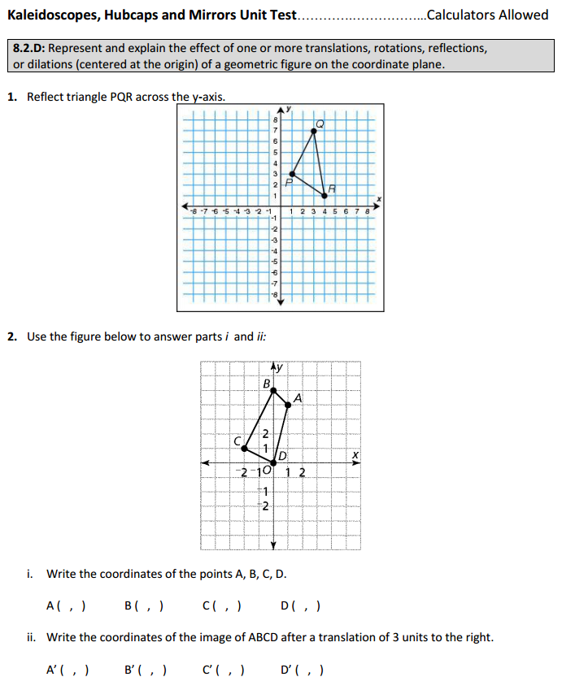

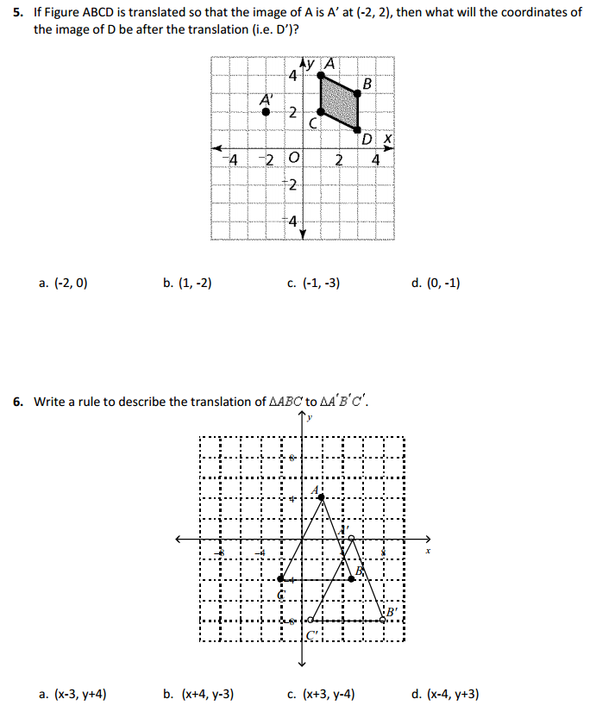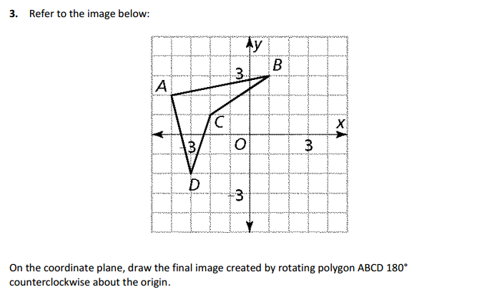

6