Name:______________________________________

Chapter 5: Systems of Linear Equations Practice Test

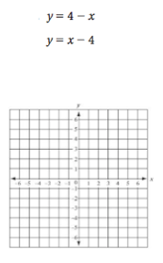
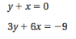

Solve the system of linear equations with the method of your choice.
